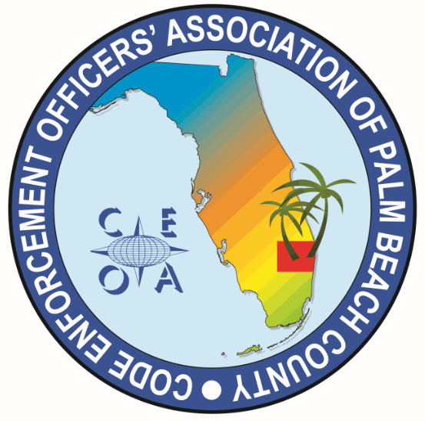

CODE ENFORCEMENT OFFICERS ASSOCIATION OF PALM BEACH COUNTY
BOARD MEETING AGENDA
JULY 8, 2025
11:30 AM
EATALIA
7750 OKEECHOBEE BLVD WEST PALM BEACH, FL 33411

CALL MEETING TO ORDER, ROLL CALL, ESTABLISH A QOURUM, RULES OF MEETING

APPROVAL OF THE MAY 12, 2025 MEETING MINUTES PRESENTED BY DWAYNE JOHNSON – MICHELLE MALKIN DANIELS

TRASURER REPORT – JOE OLIVA

OLD BUSINESS

- CONFRENCE TABLE RECAP
- THOUGHTS FROM BOARD MEMBERS IN ATTENDANCE
- AMOUNT BROUGHT IN FROM RAFFLE
- CONSIDERATION OF PHONE PAY SYSTEM NEXT YEAR

- BYLAW REVIEW COMMITTEE UPDATE – DWAYNE JOHNSON

NEW BUSINESS
- FUTURE TRAINING SPEAKERS AND LOCATIONS – SONJA BINS
- NOAA, ROBERT GARCIA, “HURRICANE PREPARDNESS FOR CODE ENFORCEMENT OFFICERS” CITY OF DELRAY BEACH 9:00 AM TO 11:00 AM, JULY 30, 2025 CONFIRMED.

- CEOAPBC MEMBERSHIP DUES $27 DUE OCTOBER 1ST AND ARE DELIQUENT DECEMBER 1ST SEND FIRST NOTICE OUT AUGUST 13TH
- REVIEW MEMBERSHIP LIST. CONTACT JURISDUCTIONS THAT ARE NOT CURRENTLY MEMBERS, RIVERA BEACH, OCEAN RIDGE MANALAPAN, ECT.

- ITEMS TO BE CONSIDERED FOR NEXT MEETING AGENDA

- SET NEXT MEETING DATE AND TIME
- BERRY FRESH HAS A MEETING ROOM (OKEECHOBEE AND JOG)

ADJOURNMENT

